Brand:
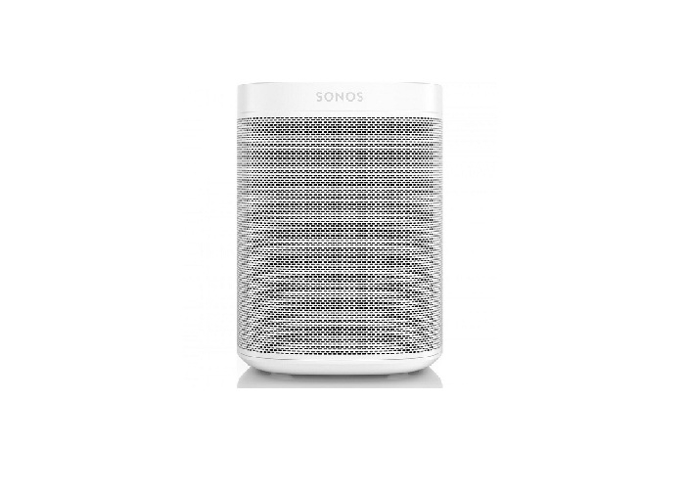
Sonos
Model:
ONEG1UK1

Weight in Kg:

90.0000

Color:
Black
System
Wireless Stereo and Network
Output Power
Auto-switching 100 - 240 VAC, 50/60 Hz universal.
Frequency

One tweeter creates a crisp and accurate high frequency response.

