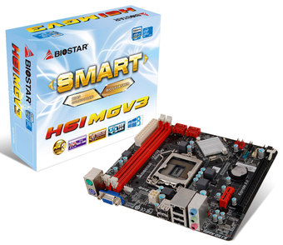 | H61MGV3 7.0/7.4  - Socket LGA 1155  - Supported the Intel 3rd and 2nd generation Core i7/ i5/ i3 processors in the 1155 package  - Supported 2 DIMM of DDR3 1600/1333/1066MHz  - Supports BIO-Remote 2 Technology

Chipset | - Intel H61
CPU SUPPORT | - Intel® Core™ i7 LGA 1155 Processor  - Intel® Core™ i5 LGA 1155 Processor  - Intel® Core™ i3 LGA 1155 Processor  - Intel® Pentium® LGA 1155 Processor  - Maximum CPU TDP (Thermal Design Power) : 95Watt
MEMORY | - Support Dual Channel DDR3 1066/1333/1600 MHz  - 2 x DDR3 DIMM Memory Slot  - Max. Supports up to 16GB Memory
EXPANSION SLOT | - 1 x PCI-E x16 3.0 Slot (supported by Core i5 -3xxx / Core i7 3xxx CPU)  - 1 x PCI-E x1 2.0 Slot
STORAGE | - 4 x SATA2 Connector
USB | - 4 x USB 2.0 Port  - 2 x USB 2.0 Header
LAN | - Realtek RTL8111G - 10/100/1000 Controller
INTEGRATED VIDEO | - By CPU model
CODEC | - VIA VT1705CF 6-Channel HD Audio
REAR I/O | - 1 x PS/2 Mouse  - 1 x PS/2 Keyboard  - 4 x USB 2.0 Port  - 1 x VGA Port  - 1 x RJ-45 Port  - 3 x Audio Connector
INTERNAL I/O | - 2 x USB 2.0 Header  - 4 x SATA2 3Gb/s Connector  - 1 x Front Audio Header  - 1 x Front Panel Header  - 1 x CPU Fan Header  - 1 x System Fan Header  - 1 x Serial Header
DIMENSION | - Micro ATX Form Factor Dimension: 19.1cm x 17cm ( W x L )
OS SUPPORT | - Support Windows XP / Vista / 7 / 8
BUNDLE SOFTWARE | - BIO-Remote2
ACCESSORIES | - 2 x SATA Cable  - 1 x I/O Shield  - 1 x DVD Driver  - 1 x Quick Guide
FEATURES | - Windows 8 Ready  - Supports 100% Solid capacitor  - Supports BIOS-Flasher  - Supports Charger Booster  - Supports BIOS Online Update

